VSEPR and Molecular Shapes

Introduction
VSEPR (Valence Shell Electron Pair Repulsion) is an acronym for a theory that predicts the shape that different molecules will take based on the idea that high concentrations of electrons will repel each other and find a position that gets them the maximum distance possible from other electron concentrations.

Areas of electron concentration can include covalent bonds or unbonded electron pairs. Identify the areas of electron concentration in these examples.

Formula | Lewis Structure | Areas of Electron Concentration
CO₂ | 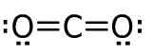
SO₂ | 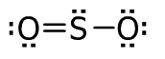
NO₃⁻ | 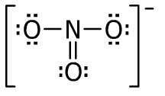
CH₄ | 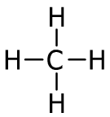
NH₃ | 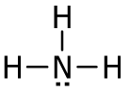
OH⁻ | 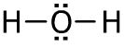

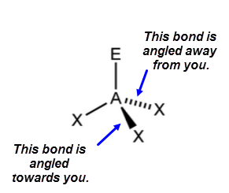
Geometric Notation
As molecules have three-dimensional shapes, two new notations
must be used. Solid black triangles show bonds angled towards the reader.
Dashed lines show bonds angled away from the reader.

Lewis Structure | Areas of Electron Concentration | Central Atom Bonds | Picture | Shape | Bond Angle
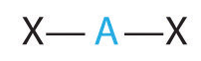 |  |  | 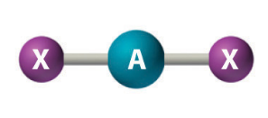 | Linear | 180º
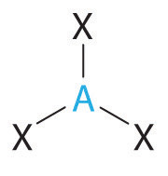 |  |  | 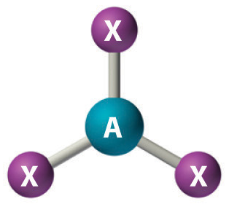 | Trigonal Planar | 120º
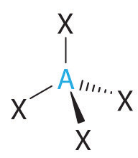 |  |  | 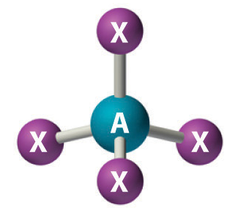 | Tetrahedral | 109.5º
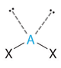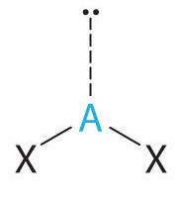 |  |  | 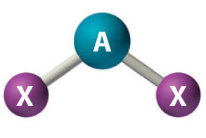 | Bent | 109.5º
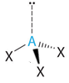 |  |  | 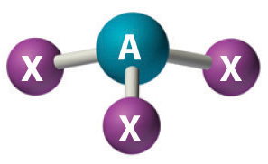 | Trigonal Pyrimidal | 109.5º

Practice
Draw a geometrically-accurate Lewis dot structure for each of these compounds. Identify the shape formed by each molecule.

PF₃

HCN

H₂S

CCl₄

CO₂

CH₄

CH₂O

