Lewis Dot Structures

Introduction
Lewis Dot structures are a way of drawing atoms and molecules to show the location and sharing of their outer valence electrons. Each electron is drawn as a dot around the chemical symbol of the element.

- Hydrogen and helium can have a maximum of two dots.
- All other elements can have a maximum of eight dots.

Example
When given an atom, such as carbon, you have to determine how many valence electrons it has. Remember, valence electrons follow this pattern on the periodic table:

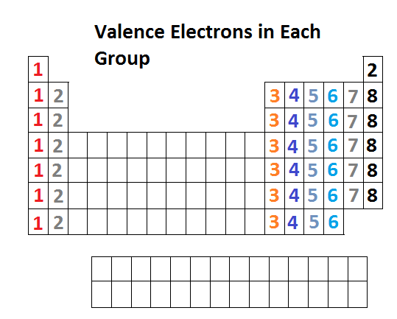
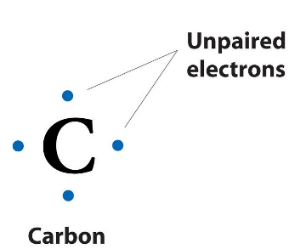
To make the Lewis dot structure, write the symbol for carbon, then begin surrounding it with electrons. Each of the four sides of the symbol can have up to two electrons. Give each side its own electron first, only double-up if you have more than four!

Carbon only has four valence electrons, so unpaired electron goes on each side.

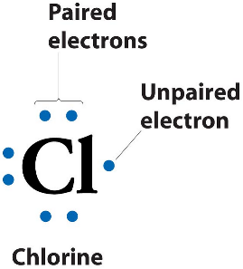

Chlorine has seven valence electrons, so three of the sides have paired electrons.

Practice
Write a Lewis Dot structure for each atom.

Ca H

Ne S

C N

Li F

B He

Making Compounds
To make compound using Lewis Dot structures, you first have to make a structure for each atom. Then, find a way to combine each of the elements so that there are no unpaired electrons.

Look at this example for ammonia. Each hydrogen atom has one unpaired electron. Nitrogen has three unpaired electrons. When combined, they can form bonding pairs, where each atom shares an electron and forms a covalent bond.
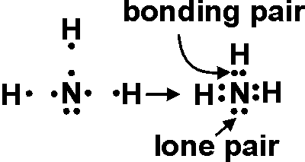

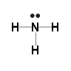
Lines are drawn to show pairs of shared electrons.

You can share up to three pairs (six total) electrons between each atom. See this example, where the oxygen atoms each share an electron, making a double bond with two pairs of electrons. Oxygen shares two pairs, so it has two lines in between.

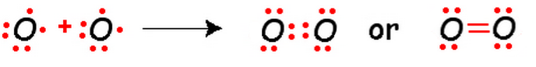
A correctly assembled covalent compound should not have any unpaired electrons!

Make a Lewis Dot structure for each of these covalent compounds.

HCl H₂O

CH₄ Cl₂

CO₂ N₂

Polyatomic Ions
Polyatomic ions have either gained or lost electrons. Their Lewis Dot structures are drawn like usual, but electrons are either added or missing depending on the charge.

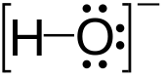
For example, hydroxide has a -1 charge, so it has one additional electron. The ion is placed in brackets to show that it has a charge.

Make a Lewis Dot structure for each of these polyatomic ions.

CN⁻

NH₄⁺

ClO⁻

Resonance Structures
Some Lewis Dot structures can be drawn with more than one configuration. In this example of sulfur trioxide, there are three possible places to put the double-bond. These are called resonance structures.
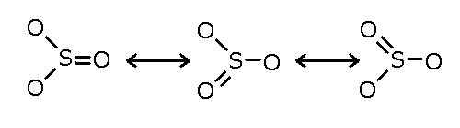

Draw the missing configurations to complete these resonance structures.
