Metallic and Ionic Bonding

Metallic Bonding

- List the four unique qualities of metals:

- There must be ______________________ between the atoms within the metal to account for these properties.

- What happens when a large number of metal atoms come together?

  - Electrons are __________________ throughout the metal.

- What holds the atoms within a piece of metal together?

- Only the ______________ electrons are shared within the electron cloud of a metal.

  - Why do transition metals have the highest melting point?

- Metallic bonds cannot be broken unless….

- What is an alloy?

- Why is bronze considered superior to copper for tool-making?

Ionic Bonding

- Define ion –

  - What is an anion?

  - What is a cation?

- Ions of the same charge will _____________.

- Ions of opposite charges will ______________.

- When does an ionic bond form?

- Metals tend to form ____________ and nonmetals tend to form ______________.

- Ionic compounds are usually made of a _________________ bonded to a _________________.

- When added to water, some ionic compounds ________________.

  - What does this mean?

  - This only occurs if the compound is _____________ in water.

Valence Electrons and Ionic Compounds

When two atoms chemically combine, they can either exchange or begin sharing electrons. Specifically, only the valence electrons, those in the outermost level of the atom, will be exchanged or shared.

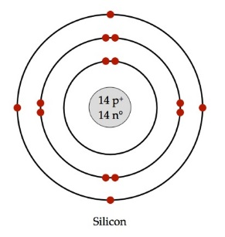
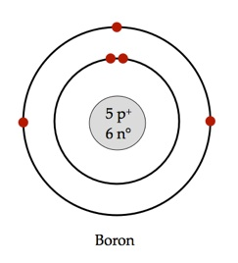
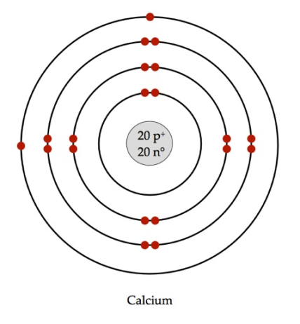
Circle and label the number of valence electrons are present in this each of these atoms.
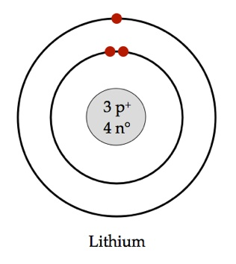

Did you notice a pattern? Each of these elements is from a different family on the periodic table. Each element within the same family has the same number of valence electrons.

All elements, in order to achieve stability, want to have a full outer ring of electrons. For most elements, the magic number is 8. This is the octet rule. Elements can do this by forming ions; by taking or giving away electrons.
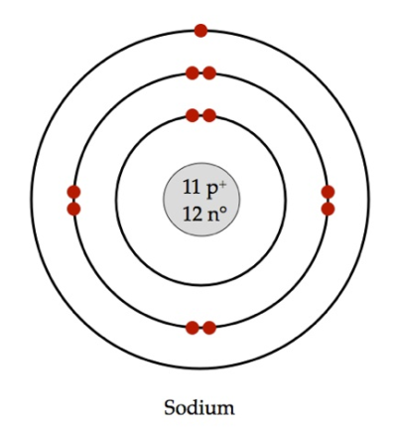

How many valence electrons does sodium have?

Would it be easier to have a full octet by gaining or losing electrons?

How many electrons would it need to gain/lose?

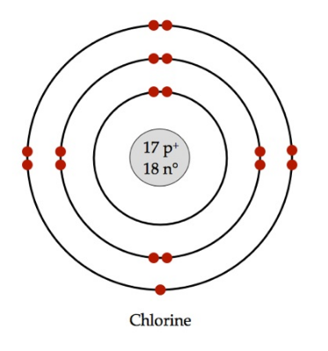

How many valence electrons does chlorine have?

Would it be easier to have a full octet by gaining or losing electrons?

How many electrons would it need to gain/lose?

Sodium and chlorine make a good pair, because one wants to gain an electron, while the other wants to give one away. By exchanging the electron and forming ions, each fulfills the octet rule. The resulting compound is named after the two elements it is made of, with the last one ending in –ide.

Na⁺ + Cl⁻ → NaCl This compound is called sodium chloride.

If we wanted to do the same reaction with calcium, we would need two chlorines. With ionic compounds, the overall net charge must be zero.

Ca²⁺ + 2Cl⁻ → CaCl₂ This compound is called calcium chloride.

Practice
Write the ionic charge above each element given below. Write a balanced formula for the compounds if the two elements combined. Name each compound.
₊₃ ₋₁
- Al + Cl AlCl₃ Aluminum Chloride

- K + F

- Sr + Br

- Li + P

- Mg + S

- Beryllium and nitrogen

- Cesium and oxygen

- Hydrogen and sulfur

- Calcium and phosphorus

- Barium and iodine

Name each of these compounds.

- Na₂O

- MgBr₂

- CsF

Write a balanced ionic formula for each of these compounds.

- Radium phosphide

- Magnesium iodide

- Strontium selenide

Naming Compounds with Transition Metals

Transition Metals
Transition metals are the elements in the middle of the periodic table, from group 3 through 12.
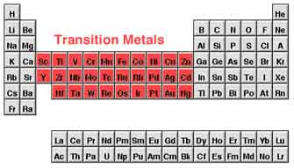
While the other families have a definite number of valence electrons and always from ions of the same charge, transition metals are a bit complicated. Many of them actually form multiple ions?

Vanadium, for example actually has 4 oxidation states! For each ion listed, write the compound it would make with the chloride ion Cl⁻.

V⁺⁵ VCl₅___________
V⁺⁴ _______________
V⁺³ _______________
V⁺² _______________

With this in mind, when we name ionic compounds with transition metals, the oxidation state must be specified with a Roman numeral. Name each of the compounds made with iron below:

FeCl₆ Iron(VI) Chloride
FeCl₃ _______________________
FeCl₂ _______________________
FeCl _______________________

Practice
Write the formula for each of the transition metal ionic compounds.

- Chromium(VI) bromide

- Nickel (II) chloride

- Zinc (II) oxide

- Zirconium (IV) phosphide

- Palladium (IV) oxide

- Silver (I) phosphide

- Niobium (V) sulfide

- Antimony (III) iodide

- Copper (II) chloride

- Vanadium (V) oxide

Write the name of each of these transition metal ionic compounds.

- MoCl₆
- ZnO
- FeBr₃
- NiS
- Os₃P₄
- SnI₄
- YCl₃
- Co₂S₃
- RuF₃
- TiO₂

Compounds with Polyatomic Ions

Polyatomic
The prefix poly- means “many.” Polyatomic ions, like other ions, have a charge. However, they are made of more than one atom bonded together. Because polyatomic ions chemically behave like single atoms, they are given special names.

For example,

PO₄⁻³ is phosphate.

CO₃⁻² is carbonate.

Let’s say you combine the Li⁺ cation with the PO₄⁻³ anion, making lithium phosphate.

What would be the chemical formula of lithium phosphate?

____________________

What would be the chemical formula of lithium carbonate?

____________________

A full listing of all polyatomic ions you will be using in this class is on the back of your periodic table.

Practice
Write the formula for each of these polyatomic compounds. Make sure the formula is balanced – there must be no net charge!

- Sodium nitrate
- Hydrogen cyanide
- Magnesium bromate
- Manganese (II) chromate
- Mercury (I) dichromate

- Ammonium hydroxide
- Tin (IV) bromate
- Aluminum hydroxide
- Chromium (III) nitrate
- Titanium (IV) arsenate
Write the correct name of each of these compounds that contain polyatomic ions. Remember, transition metals must have a Roman numeral indicating their ionic charge.

- NaClO  - H₂O₂  - CaSiO₄  - FeCO₃  - ZrNO₂ | - Ag₂Cr₂O₇  - KMnO₄  - Au₂SO₄  - Ca₃(PO₄)₂  - Co₂(CO₃)₃

Electronegativity and Chemical Bonding

Introduction
Electronegativity is a measurement of the tendency of an atom to attract electrons. The most commonly used scale to compare electronegativity is the Pauling Scale. On this scale, the most electronegative element (Fluorine) is given a value of 3.98. The least electronegative element (Francium) is given a value of 0.70. The other elements fall somewhere in between.

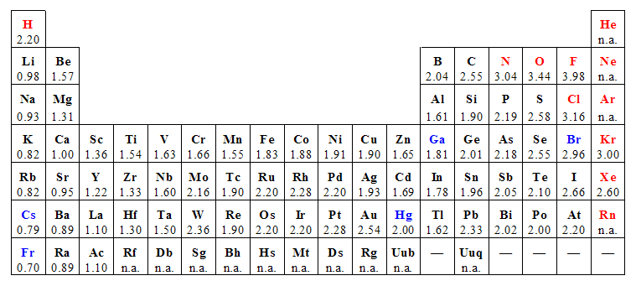
Electronegativity Difference
The type of bond that two elements may form can be predicted by subtracting the electronegativity of each one.
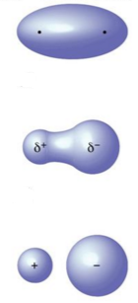
Nonpolar covalent compounds occur when there is equal sharing of electrons between the two atoms. A difference of less than 0.5 will result in a nonpolar covalent bond.

Polar covalent compounds occur when there is unequal sharing of electrons between the two atoms. An electronegativity difference of 0.5-2.0 will result in a polar covalent bond.

Ionic compounds occur when there is a transfer of electrons from one atom to another. An electronegativity difference of greater than 2.0 will result in an ionic bond.

Questions

- Describe the trend of electronegativity as you go down a group.

- Describe the trend of electronegativity as you go across a period.

- Which alkaline earth metal is the most likely to attract an electron pair?

- Which halogen is the least likely to attract an electron pair?

- Why do most of the noble gases not have an electronegativity value?

- Write the formula for each compound. Calculate the electronegativity difference and classify the type of bond they would form.

Calculate the electronegativity difference between each pair of atoms. Write the formula of the compound and indicate whether it is ionic, polar covalent, or nonpolar covalent.

Compound | Formula | Electronegativity Difference | Type of Bond
Lithium fluoride | LiF | 4.0 – 1.0 = 3.0 | Ionic
Nitrogen monoxide | NO | 3.4 – 3.0 = 0.4 | Nonpolar Covalent
Aluminum oxide
Selenium disulfide
Zinc (II) chloride
Oxygen (diatomic)
Carbon monoxide
Water
Sulfur hexafluoride
Hydrogen sulfide
Hydrogen (diatomic)
Sulfur dibromide
Iron (III) fluoride

Chemistry Study Guide
Unit 8 – Metallic, Ionic, and Covalent Bonding

Vocabulary
These are new terms that you are likely to see on the test. Briefly define each in your own words.

- Valence Electrons –
- Cation –
- Anion –
- Polyatomic Ion –
- Dissociation –
- Alloy –
- Electronegativity –
- Resonance Structure –
Critical Thinking
Be able to read, analyze, and give complete answers to questions like these.

- Use the terms below to complete the passage. No terms are repeated.

Anion Cation Chemical bond Covalent Bond Electrons

Electrostatic Ionic Bond Octet Valence Electrons

The force that holds two atoms together is called a(n) __________________. Such an attachment may form by the attraction of the positively charged _______________________ of one atom for the negatively charged _______________________ of another atom. This attraction is described as the _______________ force. This specific type of bond is called a(n) __________ bond. In other compounds, the atoms will share one or more of their ___________. This will create a _____________ bond. In either case, the atoms involved will end up with a set of eight _____________ electrons. This is called a stable _____________.

- Explain the “sea of electrons” phenomenon that occurs in metallic bonding.

- Give one example of an alloy and the parent metal(s) that it is made of.

- Write metallic, ionic, or covalent in the blanks after each statement.

  - Causes the highest known melting and boiling points. ______________

  - Dissociate when dissolved in water. ______________

  - Occurs between atoms with a small electronegativity difference. ______________

  - Occurs between atoms with a large electronegativity difference. ______________

  - Involves the creation of a positive cation and negative anion. ______________

- Explain the force behind metallic bonds that holds the atoms of metals together, giving them such high melting points and boiling points.

  - In general, which metals in the periodic table have the highest melting and boiling points?

- What are three other properties of metals besides their high melting and boiling points?

- All ionic compounds contain an anion and cation. Anions are ions with a _____________ charge. Cations are ions with a ____________ charge.

- Write the ion that each of these atoms would form. Indicate whether it is a cation or anion.

Element | Valence Electrons | Ion | Cation or Anion
Sodium | One | Na⁺ | Cation
Phosphorus
Chlorine
Beryllium
Aluminum
Nitrogen
Iodine
Potassium
Sulfur
Neon
- Write the ionic charge above each element given below. Write a balanced formula for the compounds if the two elements combined. Name each compound. Make sure to include a Roman numeral for transition metal compounds.

Atoms | Electronegativity Difference | Type of Bond | Formula | Name
Ca + Cl
Fe + O
O + F |  |  | OF₂
Cr + Cl |  |  |  | Chromium (IV) bromide
S + F |  |  | SF₆
N + O |  |  |  | Dinitrogen pentaoxide
Cs + F |  |  | CsF
C + Cl |  |  |  | Carbon tetrachloride
K + P
H + O |  |  |  | Water
N + N |  |  |  | Nitrogen Gas

- Write the formula for each of these polyatomic ionic compounds.

  - Aluminum sulfate

  - Copper (II) phosphate

  - Ammonium carbonate

- Write the formula for each of these acids.

- Hydrobromic acid

- Nitrous acid

- Bromic acid

- Single covalent bonds form when atoms share ___________ pairs of electrons. Double bonds form

when atoms share ___________ pairs of electrons. Triple bonds form when atoms share ___________

pairs of electrons.

- These three diagrams represent a nonpolar covalent bond, polar covalent bond, or ionic bond between two atoms. Label each.

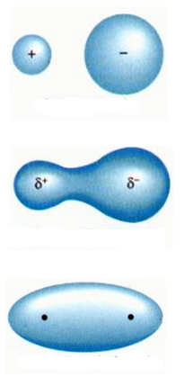
- Write the formula for each of these covalent compounds.
  - Carbon tetrabromide

  - Xenon octafluoride

  - Dinitrogen decaoxide

- Write a Lewis dot structure for each of these elements:

Si Al I Ar

- Write a Lewis dot structure for each of these compounds. Indicate what geometric shape the molecule will be according to the VSEPR model.

Molecule | Lewis Dot Structure | Atoms Bonded Around the Central Atom | Unshared Electron Pairs in Central Atom | Shape
Cl₂
OF₂
NH₃
CCl₄
O₂
CO₂
N₂
HCN

- Write the Lewis Dot structure for each of these polyatomic ions.

OH⁻

ClO⁻

NH4⁺

- How many resonance structures would the following polyatomic ions have?

